Placement Portal Application
Institutes need efficient systems to manage campus recruitment activities involving companies, students, and placement drives. Currently, many institutes rely on spreadsheets, emails, or manual processes, which makes it difficult to manage company approvals, track student applications, avoid duplicate registrations, and maintain placement records.
You are required to build a Placement Portal Application web application that allows Admin (Institute), Company, and students to interact with the system based on their roles.
Frameworks to be used
These are the mandatory frameworks on which the project has to be built.
- Flask for application back-end
- Jinja2 templating, HTML, CSS and Bootstrap for application front-end
- SQLite for database (no other database is permitted)
- JS should NOT be used for executing the core requirements
Note:
- All demos should be possible on your local machine.
- The database must be created programmatically (via table creation or model code).
- Manual database creation (such as using DB Browser for SQLite) is NOT allowed.
Roles & Functionalities
- Admin (Institute Placement Cell)
- Admin is the pre-existing superuser of the application.
- Can approve or reject company registrations.
- Can approve or reject placement drives created by companies.
- Can view and manage all students, companies, and placement drives.
- Can edit, delete or blacklist students and companies if required.
- Can search students or companies by name or ID.
- Company
- Can register and create a company profile.
- Can log in only after admin approval.
- Can create placement drives (job postings).
- Can view student applications for their drives.
- Can shortlist students and update application status.
- Student
- Can register, log in, and update their profile.
- Can view approved placement drives.
- Can apply for placement drives.
- Can view application status and placement history.
Key Terminologies
- Admin (Institute): A user with the highest level of access who manages companies, students, and placement activities.
- Company: An organization registered in the system that conducts placement drives and recruits students.
- Student: A user who applies for placement drives and participates in recruitment activities.
- Placement Drive: A recruitment drive created by a company.
Attributes:
- Drive ID
- Company ID
- Job Title
- Job Description
- Eligibility Criteria
- Application Deadline
- Status (Pending / Approved / Closed)
- Extra fields etc.
5. Application: A record of a student applying to a placement drive.
Attributes:
- Application ID
- Student ID
- Drive ID
- Application Date
- Status (Applied / Shortlisted / Selected / Rejected)
- Extra fields etc.
6. Company Profile: Details of a registered company.
Attributes:
- Company ID
- Company Name
- HR Contact
- Website
- Approval Status
- Extra fields etc.
Note: The above tables and fields are not exhaustive. Students may add additional tables and fields as required.
Similar Apps
- https://internshala.com/
- https://www.naukri.com/
- https://www.indeed.com/
Application Wireframe
Placement Portal Application
Note:
The provided wireframe is intended only to illustrate the application's flow and navigation.
Exact UI replication is NOT mandatory.
Students are encouraged to design their own UI while maintaining the application's intended functionality.
Core Features
- Authentication:
- Login system for admin, Company, and student.
- Registration is allowed only for Company and Student.
- Admin must pre-exist in the database (no admin registration).
- Admin Functionalities:
- The admin dashboard must display the total number of students, total number of companies, applications, and the total number of placement drives.
- Admin can approve or reject company registrations.
- Admin can approve or reject placement drives.
- Admin can view all placement drives and applications.
- Admin can search students by name, ID, or contact information.
- Admin can search companies by name.
- Admin can blacklist or deactivate student and company accounts.
3. Company Functionalities
- Company registration and profile management.
- The company dashboard should display company details, created placement drives, and the number of applicants per drive.
- Companies can create (only after approval from admin) , edit, remove or close placement drives.
- Companies can view student applications.
- Companies can shortlist students and update selection status (Shortlisted / Selected / Rejected)
4. Student Functionalities
- Students have to self-register and login.
- Student’s dashboard should display all approved placement drives, applied placement drives and their status.
- Students can apply for placement drives.
- Students can view application status.
- Students can view past placement history.
- Students can edit their profile and upload a resume.
5. Other Core Functionalities
- Prevent multiple applications by the same student for the same drive.
- Ensure only approved companies can create placement drives.
- Update application status dynamically.
- Allow students to view only approved placement drives.
- Maintain complete application history for each student.
- Allow admin to view all historical placement data.
Recommended and/or Optional Functionalities
- API resources to interact with users, placement drives, and applications.
- Role-based access control using Flask extensions such as flask_login or flask_security.
- APIs can return JSON or be built using Flask extensions like flask_restful.
- Frontend validation using HTML5 or JavaScript.
- Backend validation inside Flask controllers.
- Clean and responsive UI using Bootstrap (no other CSS framework allowed).
- Charts for placement statistics using libraries like ChartJS.
- Any additional feature relevant to placement portal management.
Evaluation
- Students have to create and submit a project report (not more than 5 pages) on the portal, along with the actual project submission
- The report must include the following things;
- Student details
- Project details, including the question statement and how you approached the problem statement
- AI/LLM Declaration
- Frameworks and libraries used
- ER diagram of your database, including all the tables and their relations
- API resource endpoints (if any)
- Drive link of the presentation video
- If a student has used any form of AI/LLM for the project, you will need to mention the extent of use in your report (click here for the doc)
- You can find a template to create the project report (click here for project report demo)
Possible folder structure:
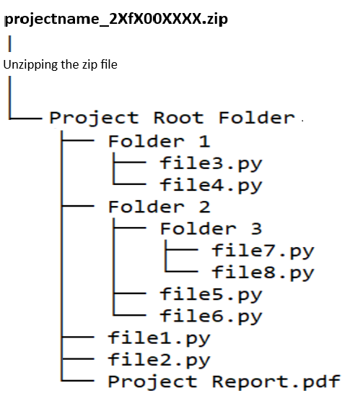
- All code is to be submitted on the portal in a single zip file (zipping instructions are given in the project document.
- Video Presentation Guidelines (Advised):
1. A short intro (not more than 30 sec)
2. How did you approach the problem statement? (30 sec)
3. Highlight key features of the application (90 sec)
4. Any additional feature(s) implemented other than core requirements (30 sec)
Note:
1. The final video must not exceed 5 – 10 minutes.
2. Keeping your video feed on during recording (like in a screencast) is optional but recommended.
- The video must be uploaded on the student drive with access to anyone with the link and the link must be included in the report:
- This will be viewed during or before the viva, so it should be a clear explanation of your work.
- Viva: After the video explanation, you are required to give a demo of your work and answer any questions that the examiner asks:
- This includes making changes as requested and running the code for a live demo.
- Other questions may be unrelated to the project itself but are relevant to the course.
Instructions
- This is a live document and may be updated.
- The problem statement will be frozen on or before 20/02/2026.
- Project submission must be a single zip file.

